Operating Systems Lab
Spring 2025
Lab # 6
Understanding RPM/YUM Package Management



Lab Instructor:
Ayesha Akram

Understanding RPM/YUM Package Management

Tarballs

When Linux was first created, most of the software used in Linux systems was passed around in tarballs. A tarball is a single archive file (created using the tar command) that can contain multiple files. So, if anyone wanted to distribute Linux software application, then distribute a tarball of those files to those who wanted to install the application. A user would untar the tarball and begin using the application. This was an old approach and had several disadvantages:

- Hard to manage: Once you installed the tarball, there was no way to manage the software. It would be hard to know which version of the software you had. Or which files are stored and what location. Because files could be spread across your file system, it could be difficult to remove the software or upgrade it.
- Dependencies: If an application depended on other software being installed, it could be a manual process to be sure that dependent software was in place and to keep that software up to date as well.

RPM

RPM is the default package installation tool used in Red Hat Linux. RPM stands for Red Hat Package Manager. All required files of an application is compiled in a single file format called with a file extension of .rpm
RPM packaging set out to solve the software management problem by packaging metadata along with the software for an application. That metadata includes version numbers, the list of files in the package, a description of the package, information about the packager, and many other items. The metadata can also
include dependencies (other software the package needs to work) and scripts (to run commands to do such things as create directories, add a user account, or turn on a service). At first, the rpm command was the primary tool created to install and manage RPM packages but still it is not good enough to resolve dependencies.

YUM

In modern days, it is recommended not to use tarballs and RPM, instead use YUM because it can automatically install and resolve dependencies.
yum command and related yum repositories and software channels are impressive.
On top of yum, there are now graphical tools (such as PackageKit) and
automated update tools for further simplifying RPM package installation and management.

YUM stands for Yellowdog Updater, Modified. Like all other program's in Linux, YUM is also an open source tool.
To install YUM, you will need APT-GET
apt-get is another basic installation system comes with every distribution of Linux.

Exercise
To check which version of yum is installed. Press following command
yum --version

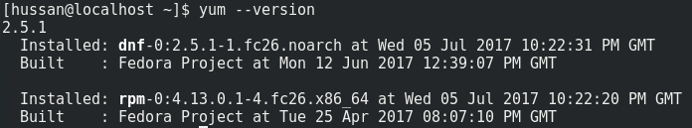

If above command does not work, and it says, yum command not found. Then you need to install YUM. To get and install yum we will use following command.

apt-get install yum (If internet connection is properly setup)

After installing yum, when you want to install any other software/package from repository using yum you can run like:

yum install httpd
If above command does not work, you can try

sudo yum install httpd

SUDO can be used at the start of any command, so we can run that command with administrative privileges.

Here httpd is package name you want to install. Generally httpd is for web/HTTP Server like apache. So general syntax to install any package is:

yum install {Package-Name}

Any package that is to be installed, at first is searched from online repository. Online repository is mentioned in /etc/yum.repos.d, contain all repository sources files.
One of file (fedora.repo) look like.

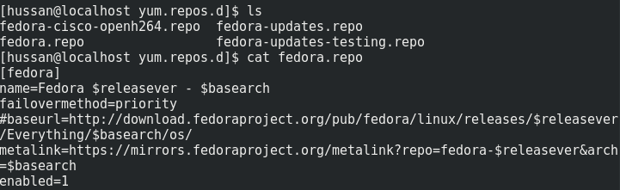
Here baseurl represent where to search for package that is needed for installation.

Exercise
Visit /etc/yum.repos.d and see how many repos file are their? Open default repo (fedora.repo) and find baseurl link.

The first step after setting up yum is to update. To update yum repository press following command.
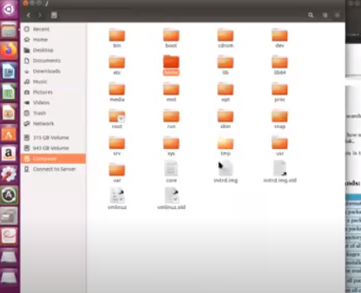

yum update

Some Basic YUM Commands:

Command | Description
yum info {package} | View information about a package
yum install {package} | install a package
yum remove {package} | remove a package
yum search {package} | search a package in repository
yum list | List repository
yum repolist | See a list of all enabled YUM repositories
yum list available | List packages available from all repositories
yum list installed | List all installed packages
yum check-update | Check for available updated packages
yum update | Update all packages with available updates
yum clean all | Clean out all cached yum data

C Programming in Linux:

In windows environment, we have seen different tools and IDEs like Visual Studio (VC++), Code::blocks and DEV-C++, but in Linux we don't have such tools, we have to use command line tool like GCC. We can compile and run C programs using GCC Compiler.

GCC

The GNU Compiler Collection (GCC) is a compiler system produced by the GNU Project. Originally named the GNU C Compiler, when it only handled the programming languages. GCC 1.0 was released in 1987. It was extended to compile C++ in December of that year. Later developed for Objective C/C++, Java, and FORTRAN.
You can check which version of gcc is installed by command: gcc –version.
If gcc not installed you can try

sudo apt install gcc

After installation, any file containing source code for C program should be saved
With the extension .c or .cpp. For example test.c.

Consider the following example: Let "hello.c" (only save files with .c extension only) be a file that contains the following C code.
#include <stdio.h>
int main()
{
printf("Hello...\n");
return 0;
}

A standard way to compile this program is with the command
gcc hello.c -o hello

This command compiles hello.c into an executable program named "hello" that you run by typing ./hello at the command line. It does nothing more than print "Hello..." on the screen.

Note: You need to have execute permission to run that file.

gcc has an option –o to specify the name of the output file. If the name of the output file is not specified, gcc names the output file a.out by default.
Once you got the source program compiled successfully, its object file is ready to be execute. To execute the object file type following command line on the prompt.

./hello
(Note:- Never type ./hello.c)
Exercise
Write a C program that asks the user to enter two number and print their sum.

Background and Foreground Processing

Since Linux is a multi-tasking system, therefore, there are number of processes running alternatively. When a command is entered through the command prompt, the operating system starts the process and the command is executed. The command prompt does not appear until the command is finished. In fact at that moment the CPU is executing the command. After the executing the command, it will re-display the prompt to indicate your process is finished. Such a processing is called foreground processing. There can only be one foreground process.

Background Processing

As there are number of processes are running at the same time, all the processes except foreground process, are known as background processes.

What if you want to run a command that takes minutes to execute? In that case, the system provides an option to run process in background, as long as the background programs do not require input from the keyboard.

Unless you redirect output, both background and foreground processes use terminal to display for standard output (e.g. messages, outputs, etc.). Therefore, if your background job produces output to the terminal, you will need to redirect, the output to a file.

When to run a process in background

The answer is straightforward. If a process will take a little bit long time in its execution, and does not require any keyboard input, then it would be desirable
To run the process in the background. For example, sorting a long data file. So if a time consuming process is running in background, one can continue working at the terminal on other process.

How to execute a command/process in background:

To run a command or process in background, the command or process must follow by & (ampersand) sign.

Example

If you have a large numeric data file to be sorted, it may take few seconds for processing. You batter run sort command as background process like this:

sudo yum install java-devel &

The system will display process id of sort command, and returns the prompt ($), while the sort command will be running in back ground.

Exercise

Try to run different commands as background processes.

The ps Command

It is used to display the currently running processes on Unix/Linux systems. If you know the 'Task-Manager" which pops up under Windows NT/2000/XP/7 when you press CTRL+ALT+DEL then you will quickly grasp what ps does on Linux.

Terminating a Process

Not all programs behave normally all the time. A program might be in an infinite loop or waiting for resources that are not available. Linux provides kill command to terminate the unwanted process. The kill command sends a signal to the specified process. The signal is an integer number, and the process is identified by the process ID number (PID).

$ kill -9 5432

Here –9 is kill signal and 5432 is process ID, which is going to be killed.

First use ps command to list the processes.

Exercise

Write C program having infinite loop like

int x=1;
while(1)
{
printf("Running %d\n",x);

And run above program in background and foreground and observe that while running in background, you can perform other command or operation while running in foreground you cannot perform other tasks.

Tasks
- Write a C program that print your name and sap id and Show the output.
- Write a C program that asks the user to enter a number and determine whether the number entered is even or odd.
Show the output.
- Write a C program to calculate the factorial of a number using a while loop take a number from user.
- Write a C program that uses an infinite for loop to print a name continuously.
- Write a program to print average of three numbers in c program.

